**ECCS 1621 – Programming 2** Name: **_____Wyatt Fisher______________**

**Spring Semester 2021** Section: morning afternoon

**Lab 3 – Due 9 February 2021**

**P3-A:**

|  |  |  |  |
| --- | --- | --- | --- |
| **Input: year** | **Expected output** | **Actual output** | **Verification** |
| 2018 | April 1 | April 1 | **🗸 ×** |
| 2016 | March 27 | March 27 | **🗸 ×** |
| 2014 | April 20 | April 20 | **🗸 ×** |
| 2008 | March 23 | March 23 | **🗸 ×** |
| 2017 | April 16 | April 16 | **🗸 ×** |
| 2024 | March 31 | March 31 | **🗸 ×** |
| Moo. | error message | Invalid year (dialog box) | **🗸 ×** |

Submit: you .java file(s) and 3 screenshots of your programming running (where one of those shows the error message)

**Test 1:**

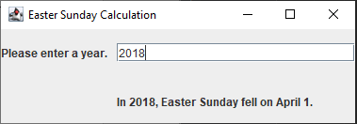

**Test 2:**

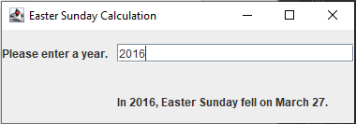

**Test 3:**

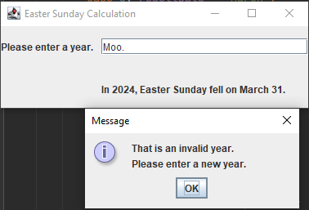

**P3-B:**

|  |  |  |  |  |  |  |  |  |  |  |  |
| --- | --- | --- | --- | --- | --- | --- | --- | --- | --- | --- | --- |
| **Input A** | **Input B** | **Input C** | **Length**  **AB** | **Length**  **AC** | **Length**  **BC** | **Angle**  **A, deg.** | **Angle**  **B, deg.** | **Angle**  **C, deg.** | **Perim.** | **Area** | **Verification** |
| (0.0, 0.0) | (1.0, 0.0) | (0.0, 1.0) | 1.00 | 1.00 | 1.41 | 90.00 | 45.00 | 45.00 | 3.41 | 0.50 | **🗸 ×** |
| (-2.5, -2) | (3.5, -2) | (0.5, 3.2) | 6.00 | 6.00 | 6.00 | 60.02 | 60.02 | 59.96 | 18.01 | 15.60 | **🗸 ×** |
| (-5, 0) | (10, 5) | (5, 0) | 15.81 | 10.00 | 7.07 | 18.43 | 26.57 | 135.00 | 32.88 | 25.00 | **🗸 ×** |

Submit: you .java file(s) and 2 screenshots of your program running

**Test 1:**

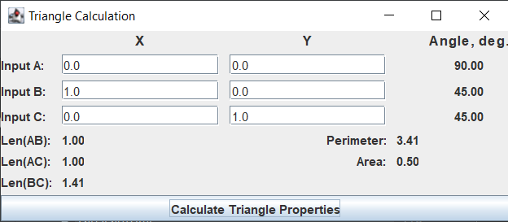

**Test 2:**

